Sennheiser's TeamConnect Ceiling Medium Microphone Wins 2024 Red Dot Award for Outstanding Product Design

WEDEMARK, Germany — July 15, 2024 — Sennheiser, the first choice for advanced audio technology that makes collaboration and learning easier, has been awarded a prestigious Red Dot Award for TeamConnect Ceiling Medium (TCC M) microphone in the Conferencing Microphone Category. The Red Dot honor comes on the heels of an iF Design Award, making it two significant design awards won by the TCC M this year.

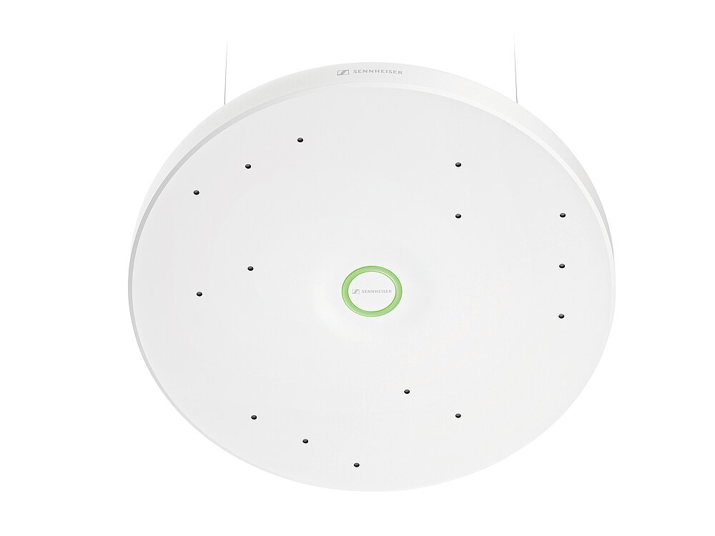
The Red Dot Design Award, established in 1955, is one of the world's largest and most distinguished design competitions. This award acknowledges TCC M’s high-quality design and innovation and serves as a quality seal for excellent design.

Statement by the Red Dot Jury:
“Like a sleek, elegant UFO, the TeamConnect Ceiling Medium (TCC M) blends unobtrusively into the room and ensures good sound during hybrid conferences.”

TeamConnect Ceiling Medium Microphone
Sennheiser’s TCC M offers unparalleled audio quality combined with automatic dynamic beamforming technology to capture voices from every corner of the room. With TruVoiceLift and its most recently added feature, Intelligent Noise Control, TCC M is an ideal choice for medium-sized meeting spaces.

TCC M is part of the Sennheiser TeamConnect Family, which also includes the TeamConnect Ceiling 2 and TeamConnect Bars. This range offers a comprehensive solution for all corporate and educational communication needs, ensuring smooth, productive, and engaging meetings or lectures for all participants.

The Red Dot Award in Product Design sets out to find the year’s best products. The products selected by the Red Dot Jury to win an award may be aesthetically appealing, functional, smart or innovative, but most of all, feature outstanding design.

“The Red Dot Award underscores our commitment to exceptional product design,” said Jens Werner, product manager, Business Communications Conferencing at Sennheiser. “Our team worked hard to achieve a thoughtful product that blends design and functionality to create the most innovative audio solution for ensuring every voice is heard in collaborative and learning environments. We’re thrilled that the Red Dot Jury recognized and selected the TCC M as a product of remarkable design.”

To view the TCC M’s inclusion amongst the 2024 Red Dot winners, go to www.red-dot.org/project/teamconnect-ceiling-medium-tcc-m-71038. For more information about Sennheiser's award-winning TCC M, please visit www.sennheiser.com/tccm.
###

About the Sennheiser brand
We live and breathe audio. We are driven by the passion to create audio solutions that make a difference. Building the future of audio and bringing remarkable sound experiences to our customers – this is what the Sennheiser brand has represented for more than 75 years. While professional audio solutions such as microphones, meeting solutions, streaming technologies and monitoring systems are part of the business of Sennheiser electronic GmbH & Co. KG, the business with consumer devices such as headphones, soundbars and speech-enhanced hearables is operated by Sonova Holding AG under the license of Sennheiser.

www.sennheiser.com
www.sennheiser-hearing.com

